2022 Deferred Physics exam HL

1.
A student carried out a laboratory experiment to verify the principle of conservation of momentum.
During the experiment body A, moving at a constant velocity, was made to collide with body B, which was at rest. Both bodies then moved on together with a common velocity.
The mass of body A was twice that of body B.
- Draw a labelled diagram of the experimental arrangement that the student could have used.

The student measured the velocity of the moving body before the collision and the velocity of the combined bodies after the collision.

- Describe how the student could have made these measurements.
- What additional steps could the student have taken in order to make these measurements more accurate?
- Why should body A be moving with a constant velocity before the collision?
- How did the student check this?
- The velocity of the combined bodies was found to be 0.18 m s⁻¹.
If the experiment had indeed verified the principle of conservation of momentum, what velocity would you expect body A to have had before the collision?

2.
In an experiment to measure the specific latent heat of vaporisation of water, steam was added to water that had been cooled to below room temperature.
- Draw a labelled diagram of the apparatus that the student could have used in the experiment.

The following readings were made:
Mass of aluminium calorimeter = 25.6 g
Room temperature = 19 °C
Mass of calorimeter and water = 75.3 g
Initial temperature of water = 12 °C
Final mass of calorimeter and water = 76.6 g
Temperature of steam = 100 °C
Final temperature of water = 26 °C

- Given that the specific heat capacity of aluminium is 910 J kg^{–1} K⁻¹ and the specific heat capacity of water is 4180 J kg^{–1} K⁻¹, calculate the specific latent heat of vaporisation of water.

- Why did the student use water that that had been cooled to below room temperature?
- The student decided to repeat the experiment using a greater mass of steam.
Discuss one advantage and one disadvantage of using a greater mass of steam.

3.
In an experiment to measure f, the focal length of a concave mirror, a student first found an approximate value for the focal length.
Then the student recorded the image distance v for different values of the object distance u.
u (cm) | 25.0 | 30.0 | 35.0 | 40.0
v (cm) | 70.1 | 44.1 | 36.4 | 33.1
The student recorded the data in the following table:

- What is meant by the focal length of a concave mirror?
- How did the student find an approximate value for the focal length?
- Why did the student find an approximate value for the focal length?
- Describe how the position of the image was determined.
- Use the data in the table to calculate the focal length.

The student later carried out an experiment to measure the focal length of a converging lens.
- Sketch the shape of a converging lens.
- How does the arrangement of the apparatus differ between the two experiments?

4.
The following is part of a student’s report on an experiment to measure the wavelength of monochromatic light with a diffraction grating.

“The apparatus, including a monochromatic light source, was arranged so that a number of bright images could be observed. The position of the central bright image was noted.
After this the angular positions of the other images were determined and the formula nλ= dsin $θ$ was used to find the wavelength of the light.”
- What is meant by the word “monochromatic”?
- Describe, with the aid of a labelled diagram, how the apparatus was arranged in this experiment.
- Explain how the value of d, and (iv) the value of $θ$ for each image, was determined.

- In carrying out this experiment the student wanted to have a large angular separation of the images.
Why would the student have wanted this?
- State one way in which the student could have achieved a larger angular separation of the images without changing the light source.
- The third order image of the monochromatic light source was obtained at an angle of 50°. If the grating being used had 400 lines per mm, calculate the wavelength of the light.
- Draw a diagram of what is observed when a beam of white light is passed through a diffraction grating.

5.
$θ$ (°C) | 20 | 30 | 40 | 50 | 60 | 70 | 80
R (Ω) | 8.1 | 8.5 | 9.0 | 9.5 | 10.0 | 10.4 | 10.9
A student was asked to investigate the variation of the resistance of a metallic conductor with temperature. The student set up a circuit using the appropriate equipment and recorded the value of the resistance, R, of the conductor as its temperature, $θ$, was changed.
The data recorded are shown in the table.

- Draw a labelled diagram of the experimental arrangement used and describe how the data in the table were obtained.
- Use the table to draw a suitable graph that shows the relationship between the resistance of the conductor and its temperature.
- Describe the relationship between resistance and temperature shown by your graph.
- Use your graph to find the rate of change of resistance with respect to temperature for the metallic conductor.
- Estimate the resistance of the metallic conductor when its temperature is –10 °C.
- Later the student carried out a similar experiment to measure the variation of resistance with temperature for a thermistor. How would the results of the two experiments differ?

6.
Answer any eight of the following parts, (a), (b), (c), etc.

  - An athlete weighing 850 N runs up a stairs in 6 seconds. If the vertical height of the stairs is 2.5 m, calculate the average power generated by the athlete.
  - State Archimedes’ principle.
  - Calculate the length of a pendulum that has a period of one second.
  - A thermocouple thermometer and an alcohol‐in‐glass thermometer each gave a different reading when placed in the same container of water. Explain why this occurred.
  - A standing wave is set up in a stretched string that is fixed at each end. Sketch the first two harmonics that are produced when the string is plucked.
  - What is meant by sound intensity?
  - Calculate the effective focal length of two thin lenses in contact, one a converging lens of focal length 5 cm and the other a diverging lens of focal length 15 cm.
  - A precaution usually taken when using electrical equipment is to put a fuse in the circuit. Explain the role of a fuse.
  - A solid copper cube of side 5 cm rests on a horizontal table. Find the pressure exerted by the cube on the table.
  - What is meant by the U‐value of a material?
  - How are X‐rays produced?

a. Name the metal used as a target in the Cockroft and Walton experiment.
or
b. A light‐emitting diode emits light of a particular colour when a current flows. What determines the colour of the emitted light?

(acceleration due to gravity, g = 9.8 m s⁻²; density of copper = 8960 kg m⁻³)

7.
- Define displacement.
- Define velocity.
- What is a vector quantity?

A swimmer wants to cross a river which is 75 m wide. The banks of the river are parallel.
The river is flowing with a velocity of 4 m s^{–1} parallel to the river banks, as in the diagram.

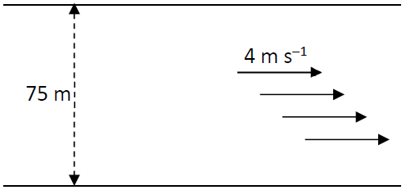

The swimmer sets out to swim across the river with a speed of 2.5 m s^{–1} perpendicular to the banks of the river.
- What is the resultant velocity of the swimmer?
- How long will it take the swimmer to reach the opposite bank of the river?
- What will be the displacement of the swimmer from his starting position when he has reached the opposite bank?
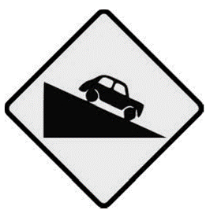
- Describe a laboratory experiment to find the resultant of two co‐planar forces.
- A car of mass 1000 kg is freely rolling downhill on a road that is at an angle of 10° to the horizontal.
If the frictional force on the car as it moves down the slope is a constant 550 N, calculate the acceleration of the car.
(acceleration due to gravity, g = 9.8 m s⁻²)

8.
- What is the Doppler effect?
- Explain how the Doppler effect occurs.

- What is meant by the emission line spectrum of an element?
- How is the emission line spectrum of an element related to the energy levels of the electrons in an atom of that element?
- Describe how you would show the emission line spectrum of hydrogen in the laboratory.
- The wavelength of the red line in the emission line spectrum of hydrogen was measured in the laboratory as 656 nm. Calculate its frequency.

In the 1920s, American astronomer Edwin Hubble, pictured, used the Doppler effect to study distant galaxies. He found that most galaxies were moving away from Earth.
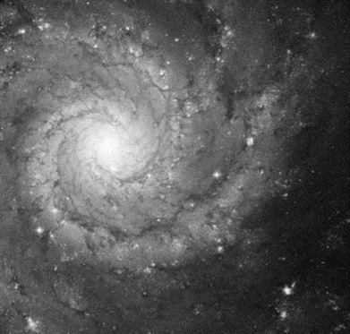
He also found that the galaxies which were furthest away from Earth were the ones which were moving with the fastest speeds.

- A certain galaxy is moving at a speed of 3 × 10⁷ m s^{–1} away from the Earth.
Astronomers on Earth analysed the light from this galaxy and measured the frequency of the red line in the hydrogen emission line spectrum.
Calculate the frequency they observed.

9.
- State Faraday’s law of electromagnetic induction.
- State Lenz’s law. of electromagnetic induction.
- Describe how you would demonstrate each of these laws in the laboratory.

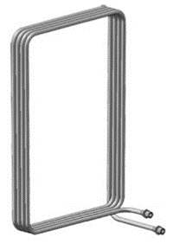
- The diagram shows a square coil of wire of side 20 cm. There are 4 turns of wire in the coil.
The coil is placed perpendicular to a magnetic field of flux density 1.5 × 10^{–3} T.
Calculate the magnetic flux through the coil.

- The coil is then moved out of the magnetic field in a direction parallel to one of the sides of the square.
If the speed at which the coil is moved is 2.5 m s^{–1}, calculate the emf induced in the coil.

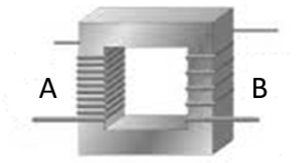
The diagram shows a transformer. The coils A and B are wound on a laminated iron core.
- What happens in coil B when an alternating voltage is applied to coil A?
- What is the purpose of a transformer?
- Describe the principle of operation of a transformer.

10.
(a) The photograph shows a flat‐screen television set.
Flat‐screen displays have replaced cathode ray tubes in most applications.
- Explain, with the aid of a labelled diagram, the operation of a cathode ray tube.
- State two of the disadvantages of cathode ray tubes that led to their replacement by flat‐screen displays.

(b) The photocell is based on the photoelectric effect.
- What information does the photoelectric effect give about the nature of light?
- What effect does the frequency of the incident light have on the current flowing in a photocell?
- Describe how you would show this effect in the laboratory.
- What effect does the intensity of the incident light have on the current flowing in a photocell?
- Describe how you would show this effect in the laboratory.
- Light of frequency 7.6 × 10¹⁴ Hz is incident on a metal that has a work function of 2.1 eV.
- Calculate the energy of a photon of the incident light,
- Calculate the energy of the most energetic electron emitted.

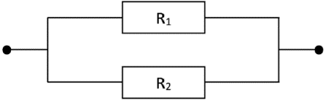
11.
- Define potential difference.
- Define resistance.
- Derive an expression for the total effective resistance of resistors R₁ and R₂ shown in the diagram on the right.

- An LDR is a light dependent resistor.
It can be used in a circuit to monitor the intensity (brightness) of light.
Describe an experiment to show how the resistance of an LDR varies with the intensity of the light falling on it.
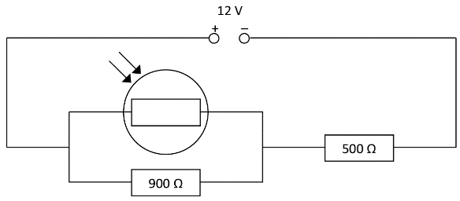
- Sketch a graph to show the relationship between the resistance of an LDR and the intensity of the light falling on it.

In the circuit diagram shown, the resistance of the LDR is 1.1 kΩ when light of a particular intensity falls on it.
- Calculate the total resistance of the circuit.
- Calculate the current flowing through the 900 Ω resistor.
- If the resistance of the LDR decreases, explain what happens to the potential difference across the 500 Ω resistor.

12.
Answer either part (a) or part (b).

(a)
CERN, based near Geneva, is the European centre for research in particle physics.
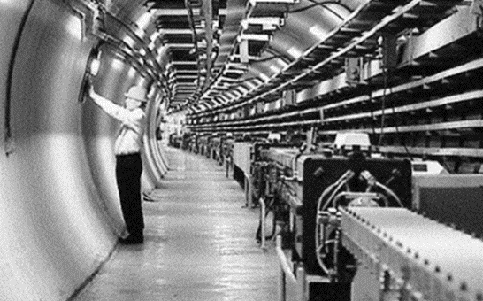
The photograph shows the particle accelerator in CERN, which is in a 27 km long circular tunnel.
The accelerator has been used to find many of the fundamental particles of matter.
Explain what is meant by the following terms:
(i) quark (ii) lepton (iii) meson (iv) baryon.
- State the quark composition of the proton and the neutron.

In a particle accelerator, two protons are accelerated to half the speed of light before being allowed to collide.
In the collision a single neutral pi meson (π⁰) is formed, as in the equation below. p + p → p + p + π⁰
- Why is it that the pi meson that is formed in the collision must be neutral?
- Assuming that the pi meson produced has a negligible speed, and that both protons have an equal speed of v after the collision, calculate v.
- Anti‐matter is composed of particles that have the same mass as particles of ordinary matter but have opposite charge. They can be created in particle accelerator laboratories such as CERN.
Name the scientist who predicted the existence of anti‐matter.

(b)
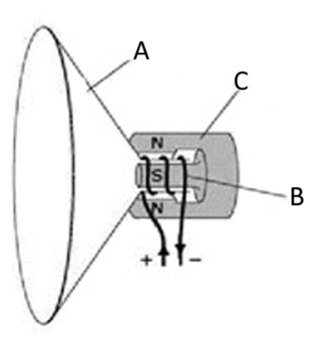
- Describe an experiment to demonstrate that a current‐carrying conductor experiences a force when placed in a magnetic field.

The diagram shows a moving‐coil loudspeaker.
- Name the parts A, B and C.
- Explain how the moving‐coil loudspeaker emits sound.

- The d.c. motor and the moving‐coil galvanometer are based on the same principle of operation as the moving‐coil loudspeaker.
Draw a labelled diagram of a simple d.c. motor.

- The circuit controlling an electric motor may contain an electromagnetic relay.
What is the function of an electromagnetic relay and how does it carry out that function?

Describe how a moving‐coil galvanometer may be arranged so as to function (vi) as an ammeter, (vii) as a voltmeter.

13.
Read the following passage and answer the accompanying questions.
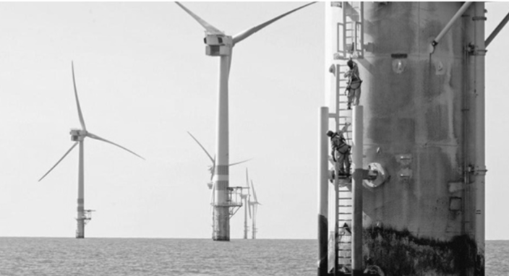
Off‐shore wind farms are making electricity suppliers look again at high‐voltage d.c. transmission to reduce operating costs. Out at sea, turbine blades turn more quickly than on land thanks to faster, more stable winds. This means that power generation shoots up because it is governed by the cube of the airstream’s velocity. The power capacity of the largest offshore turbines is currently 5 MW whereas on land it is 3 MW.

To make best use of the energy generated at sea, it must be transmitted back to the mainland in an efficient manner. For this reason the power must be transmitted to land at a very high voltage. Where turbines are more than about 80 kilometres from shore, a.c. transmission is not viable, due to very large energy losses in the transmission system.

The alternative is high‐voltage d.c. transmission. This was used in the cross‐channel link between Britain and France in the last century. More recently, China has been developing the use of high voltage d.c. to transmit electrical energy between generating stations and cities.

However transmitting electricity at high voltages places greater demands on the reliability of insulating materials used in these electrical transmission systems.
Adapted from Physics World Focus on Nanotechnology, June 2013

  - How do a.c. and d.c. differ?
  - A wind turbine has a power output of 200 kW when the wind speed is 10 m s^{–1}.
Calculate the power of the turbine when the wind speed increases to 15 m s^{–1}.
  - The average power output of a wind turbine over a period of one year was 300 kW.
Calculate the number of units of electrical energy generated by the turbine in that year.
  - The conversion of a.c. to d.c. is required for high‐voltage d.c. transmission.
Name the term used to describe this conversion.
  - Draw the electrical circuit symbol for the semiconductor device used in this process.
  - The peak a.c. voltage generated by a particular wind turbine is 690 V. Calculate the rms voltage generated.
  - The average power generated by the wind turbine described in part (e) is 1.5 MW. Calculate the rms current generated.
  - Explain why a very high voltage is required for the efficient transmission of electricity.
  - Name a material that is an electrical insulator. State one reason why an insulator is needed in the transmission of electricity.

14. Answer any two of the following parts (a), (b), (c), (d).

(a)
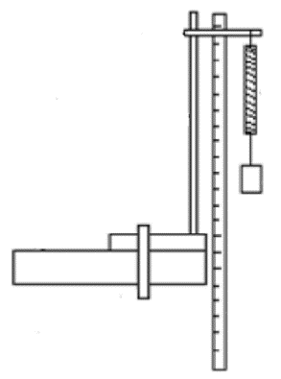
- State Hooke’s law.

- The length of the spiral spring in the diagram increases from 50 cm to 56 cm when a body of weight 0.7 N is hung from the spring.
Calculate the elastic constant of the spring.

When the body at the end of the spring is pulled down by a further short distance and then released, the mass oscillates with simple harmonic motion.
- Calculate the period of the simple harmonic motion.

At what point during its oscillation does the body have (iv) maximum velocity, (v) maximum acceleration?

(acceleration due to gravity, g = 9.8 m s⁻²)

(b)
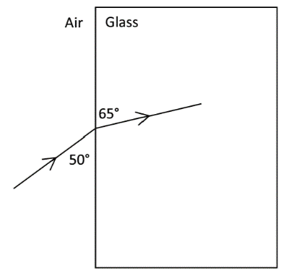
- State Snell’s law of refraction.

A ray of blue light with a wavelength of 480 nm in air is incident on a rectangular glass block, as shown in the diagram.

- Calculate the refractive index of the glass for blue light.
- Calculate the speed of this light in the glass.
- Calculate the wavelength of this light in the glass.
- A ray of red light, incident at the same point on the glass block, takes a different path in the block.
Explain why this is happens.

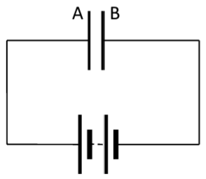
(c)
- What is a capacitor?
- Define the unit of capacitance, i.e. the farad.

A parallel plate capacitor of capacitance 3 µF has plates A and B connected across a 6 V battery, as shown in the diagram on the right.
- Calculate the charge on plate A
- Calculate the charge on plate B.
- Calculate the energy stored in the capacitor.
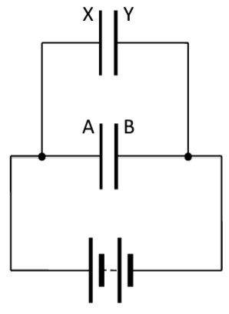
A 2 µF capacitor, with plates X and Y, is now connected in parallel with the first capacitor across the 6 V battery, as shown in the diagram on the left.
- Calculate the charge that is now on plate A.
- Calculate the charge that is now on plate B.
- Calculate the charge that is now on plate X.
- Calculate the charge that is now on plate Y.

- Calculate the capacitance of a single capacitor which could store as much energy as is stored in the two capacitors connected in parallel across the 6 V battery.

(d)
- What is meant by nuclear fission?
- The equation below gives one of the many reactions in the fission of uranium–235.
${}_{92}^{235}{U+{}_{0}^{1}n}$ → ${}_{56}^{144}Z$ +${}_{X}^{89}Z+$ 3Y + Energy

- Is this a spontaneous nuclear reaction or an induced nuclear reaction?
- What numbers or symbols do X, Y and Z represent in the above equation?

The krypton–89 isotope decays by beta‐emission to rubidium.
The decay constant for the isotope is 3.67 × 10^{–3} s^{–1}.

- Calculate the number of atoms of krypton–89 in a sample of the isotope that emits 2.0 × 10⁵ beta particles per second.
- What is the half‐life of krypton–89?

